**BÁO CÁO THỰC HÀNH KIẾN TRÚC MÁY TÍNH (IT3280) TUẦN 10_2**

***Họ và tên: Phạm Đức Long***

***MSSV: 20225737***

Assignment 1:

1. Hình tam giác đều:

* Code:

.eqv HEADING 0xffff8010 # Integer: An angle between 0 and 359

.eqv MOVING 0xffff8050 # Boolean: whether or not to move

.eqv LEAVETRACK 0xffff8020 # Boolean (0 or non-0):

.text

main:

addi $a0, $zero, 90

running:

jal ROTATE

jal GO

sleep:

addi $v0, $zero, 32

li $a0, 10000

syscall

goDown:

addi $a0, $zero, 180

jal ROTATE

sleep1:

addi $v0, $zero, 32

li $a0, 5000

syscall

jal TRACK

goASEW_1:

addi $a0, $zero, 150

jal ROTATE

sleep2:

addi $v0, $zero, 32

li $a0, 9000

syscall

jal UNTRACK

jal TRACK

goASEW_2:

addi $a0, $zero, 270

jal ROTATE

sleep3:

addi $v0, $zero, 32

li $a0, 9000

syscall

jal UNTRACK

jal TRACK

goASKEW_3:

addi $a0, $zero, 30

jal ROTATE

sleep4:

addi $v0,$zero,32

li $a0,9000

syscall

jal UNTRACK

ESC:

addi $a0, $zero, 270

jal ROTATE

sleep5:

addi $v0, $zero, 32

li $a0, 5000

syscall

end_main:

jal STOP

li $v0, 10

syscall

GO:

li $at, MOVING

addi $k0, $zero,1

sb $k0, 0($at)

jr $ra

STOP:

li $at, MOVING # change MOVING port to 0

sb $zero, 0($at) # to stop

jr $ra

TRACK:

li $at, LEAVETRACK # change LEAVETRACK port

addi $k0, $zero,1 # to logic 1,

sb $k0, 0($at) # to start tracking

jr $ra

UNTRACK:

li $at, LEAVETRACK # change LEAVETRACK port to 0

sb $zero, 0($at) # to stop drawing tai l

jr $ra

ROTATE:

li $at, HEADING # change HEADING port

sw $a0, 0($at) # to rotate robot

jr $ra

* Kết quả:

* Kết luận: Kết quả thu được đúng là tam giác cân

1. Hình vuông:

* Code:

.eqv HEADING 0xffff8010 # Integer: An angle between 0 and 359

.eqv MOVING 0xffff8050 # Boolean: whether or not to move

.eqv LEAVETRACK 0xffff8020 # Boolean (0 or non-0):

.text

main:

addi $a0, $zero, 90

running:

jal ROTATE

jal GO

sleep:

addi $v0, $zero, 32

li $a0, 10000

syscall

goDown:

addi $a0, $zero, 180

jal ROTATE

sleep1:

addi $v0, $zero, 32

li $a0, 5000

syscall

jal TRACK

goRIGHT:

addi $a0, $zero, 90

jal ROTATE

sleep2:

addi $v0, $zero, 32

li $a0, 9000

syscall

jal UNTRACK

jal TRACK

goDOWN:

addi $a0, $zero, 180

jal ROTATE

sleep3:

addi $v0,$zero,32

li $a0,9000

syscall

jal UNTRACK

jal TRACK

goLEFT:

addi $a0, $zero, 270

jal ROTATE

sleep4:

addi $v0, $zero, 32

li $a0, 9000

syscall

jal UNTRACK

jal TRACK

goTOP:

addi $a0, $zero, 0

jal ROTATE

sleep5:

addi $v0, $zero, 32

li $a0, 9000

syscall

jal UNTRACK

ESC:

addi $a0, $zero, 270

jal ROTATE

sleep6:

addi $v0, $zero, 32

li $a0, 5000

syscall

GO:

li $at, MOVING

addi $k0, $zero,1

sb $k0, 0($at)

jr $ra

STOP:

li $at, MOVING # change MOVING port to 0

sb $zero, 0($at) # to stop

jr $ra

TRACK:

li $at, LEAVETRACK # change LEAVETRACK port

addi $k0, $zero,1 # to logic 1,

sb $k0, 0($at) # to start tracking

jr $ra

UNTRACK:

li $at, LEAVETRACK # change LEAVETRACK port to 0

sb $zero, 0($at) # to stop drawing tai l

jr $ra

ROTATE:

li $at, HEADING # change HEADING port

sw $a0, 0($at) # to rotate robot

jr $ra

* Kết quả:

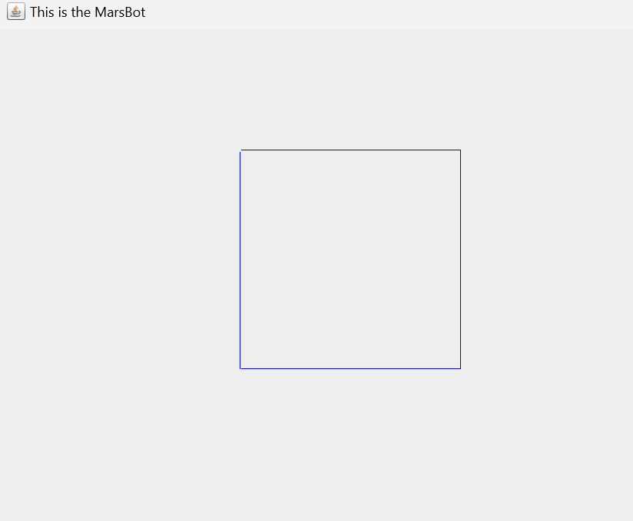

* Kết luận: Kết quả thu được đúng là hình vuông.

1. Hình ngôi sao năm cánh:

* Code:

.eqv HEADING 0xffff8010 # Integer: An angle between 0 and 359

.eqv MOVING 0xffff8050 # Boolean: whether or not to move

.eqv LEAVETRACK 0xffff8020 # Boolean (0 or non-0):

.text

main:

addi $a0, $zero, 90

running:

jal ROTATE

jal GO

sleep:

addi $v0, $zero, 32

li $a0, 10000

syscall

goDown:

addi $a0, $zero, 180

jal ROTATE

sleep1:

addi $v0, $zero, 32

li $a0, 5000

syscall

jal TRACK

goASEW_1:

addi $a0, $zero, 162

jal ROTATE

sleep2:

addi $v0, $zero, 32

li $a0, 9000

syscall

jal UNTRACK

jal TRACK

goASEW_2:

addi $a0, $zero, 306

jal ROTATE

sleep3:

addi $v0, $zero, 32

li $a0, 9000

syscall

jal UNTRACK

jal TRACK

goRIGHT:

addi $a0, $zero, 90

jal ROTATE

sleep4:

addi $v0, $zero, 32

li $a0, 9000

syscall

jal UNTRACK

jal TRACK

goASEW_3:

addi $a0, $zero, 234

jal ROTATE

sleep5:

addi $v0, $zero, 32

li $a0, 9000

syscall

jal UNTRACK

jal TRACK

goASEW_4:

addi $a0, $zero, 18

jal ROTATE

sleep6:

addi $v0, $zero, 32

li $a0, 9000

syscall

jal UNTRACK

ESC:

addi $a0, $zero, 270

jal ROTATE

sleep7:

addi $v0, $zero, 32

li $a0, 5000

syscall

end_main:

jal STOP

li $v0, 10

syscall

GO:

li $at, MOVING

addi $k0, $zero,1

sb $k0, 0($at)

jr $ra

STOP:

li $at, MOVING # change MOVING port to 0

sb $zero, 0($at) # to stop

jr $ra

TRACK:

li $at, LEAVETRACK # change LEAVETRACK port

addi $k0, $zero,1 # to logic 1,

sb $k0, 0($at) # to start tracking

jr $ra

UNTRACK:

li $at, LEAVETRACK # change LEAVETRACK port to 0

sb $zero, 0($at) # to stop drawing tai l

jr $ra

ROTATE:

li $at, HEADING # change HEADING port

sw $a0, 0($at) # to rotate robot

jr $ra

* Kết quả:

* Kết luận: Kết quả thu được đúng là hình sao năm cánh

Assignment 2:

* Code:

.eqv KEY_CODE 0xFFFF0004

.eqv KEY_READY 0xFFFF0000

.eqv DISPLAY_CODE 0xFFFF000C

.eqv DISPLAY_READY 0xFFFF0008

.text

li $k0, KEY_CODE

li $k1, KEY_READY

li $s0, DISPLAY_CODE

li $s1, DISPLAY_READY

loop:

WaitForKey:

lw $t1, 0($k1) # $t1 = [$k1] = KEY_READY

beq $t1, $zero, WaitForKey # if $t1 == 0 then Polling

ReadKey:

lw $t0, 0($k0) # $t0 = [$k0] = KEY_CODE

WaitForDis:

lw $t2, 0($s1) # $t2 = [$s1] = DISPLAY_READY

beq $t2, $zero, WaitForDis # if $t2 == 0 then Polling

Check1:

bge $t0, 48, Number

j ELSE

Check2:

bge $t0, 65, LowCase

j ELSE

Check3:

bge $t0, 97, UpCase

ELSE:

addi $t0, $zero, 42

ShowKey:

beq $t0, 69, CheckExit1

beq $t0, 88, CheckExit2

beq $t0, 73, CheckExit3

beq $t0, 84, CheckExit4

Reset:

addi $v0, $zero, 0

Show:

sw $t0, 0($s0) # show key

j loop

Number:

ble $t0, 57, ShowKey

j Check2

LowCase:

bgt $t0, 90, Check3

addi $t0, $t0, 32

j ShowKey

UpCase:

bgt $t0, 122, ELSE

addi $t0, $t0, -32

j ShowKey

CheckExit1:

bnez $v0, Reset

addi $v0, $v0, 1

j Show

CheckExit2:

bne $v0, 1, Reset

addi $v0, $v0, 1

j Show

CheckExit3:

bne $v0, 2, Reset

addi $v0, $v0, 1

j Show

CheckExit4:

bne $v0, 3, Reset

End:

li $v0, 10

syscall

* Kết quả:

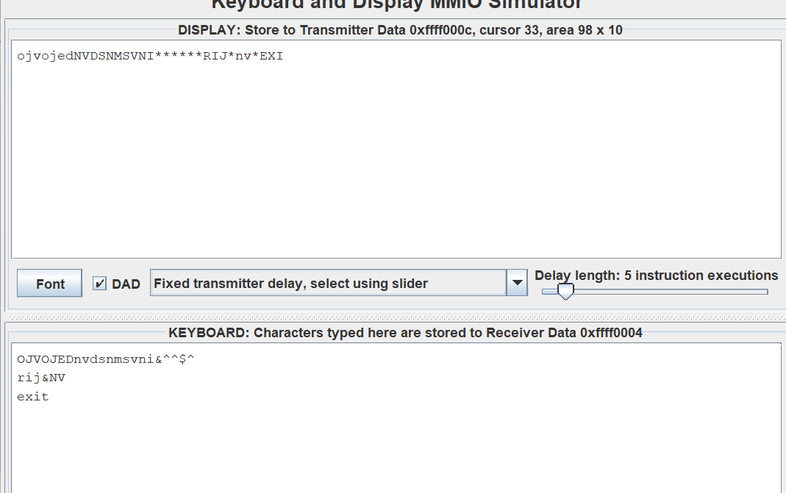

* Nhận xét: Kết quả nhận được hoàn toàn đúng với giả thuyết

Assignment 3:

* Code:

.eqv HEADING 0xffff8010 # Integer: An angle between 0 and 359

.eqv MOVING 0xffff8050 # Boolean: whether or not to move

.eqv LEAVETRACK 0xffff8020 # Boolean (0 or non-0):

.eqv KEY_CODE 0xFFFF0004

.eqv KEY_READY 0xFFFF0000

.eqv DISPLAY_CODE 0xFFFF000C

.eqv DISPLAY_READY 0xFFFF0008

.text

main:

li $k0, KEY_CODE

li $k1, KEY_READY

li $s0, DISPLAY_CODE

li $s1, DISPLAY_READY

loop:

WaitForKey:

lw $t1, 0($k1) # $t1 = [$k1] = KEY_READY

beq $t1, $zero, WaitForKey # if $t1 == 0 then Polling

ReadKey:

lw $t0, 0($k0) # $t0 = [$k0] = KEY_CODE

WaitForDis:

lw $t2, 0($s1) # $t2 = [$s1] = DISPLAY_READY

beq $t2, $zero, WaitForDis # if $t2 == 0 then Polling

Check:

beq $t0, 32, Start # show key #W87 w119 A65 a97 S83 s115 D67 d100

space32:

beq $t0, 87, goTop

beq $t0, 119, goTop

beq $t0, 83, goDown

beq $t0, 115, goDown

beq $t0, 67, goRight

beq $t0, 100, goRight

beq $t0, 65, goLeft

beq $t0, 97, goLeft

j loop

Start:

bnez $t3, Exit

addi $t3, $t3, 1

jal GO

jal TRACK

j loop

goTop:

addi $a0, $zero, 0

jal ROTATE

addi $v0, $zero, 32

li $a0, 1000

syscall

jal UNTRACK

jal TRACK

j loop

goDown:

addi $a0, $zero, 180

jal ROTATE

addi $v0, $zero, 32

li $a0, 1000

syscall

jal UNTRACK

jal TRACK

j loop

goRight:

addi $a0, $zero, 90

jal ROTATE

addi $v0, $zero, 32

li $a0, 1000

syscall

jal UNTRACK

jal TRACK

j loop

goLeft:

addi $a0, $zero, 270

jal ROTATE

addi $v0, $zero, 32

li $a0, 1000

syscall

jal UNTRACK

jal TRACK

j loop

Exit:

jal STOP

li $v0, 10

syscall

GO:

li $at, MOVING

addi $v1, $zero,1

sb $v1, 0($at)

jr $ra

STOP:

li $at, MOVING # change MOVING port to 0

sb $zero, 0($at) # to stop

jr $ra

TRACK:

li $at, LEAVETRACK # change LEAVETRACK port

addi $v1, $zero,1 # to logic 1,

sb $v1, 0($at) # to start tracking

jr $ra

UNTRACK:

li $at, LEAVETRACK # change LEAVETRACK port to 0

sb $zero, 0($at) # to stop drawing tail

jr $ra

ROTATE:

li $at, HEADING # change HEADING port

sw $a0, 0($at) # to rotate robot

jr $ra

* Kết quả:

* Nhận xét: Kết quả thu được hoàn toàn đúng với yêu cầu đề bài